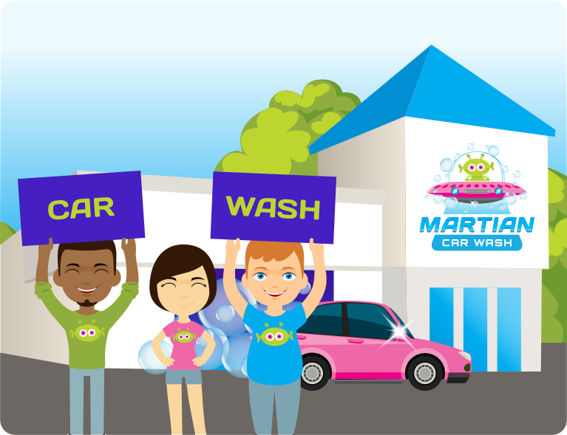
GIVE $4
SUPPORT OUR FUNDRAISER

PLACE YOUR NAME HERE

Purchase a Merle’s Best car wash
& Merle will give $4 to our fundraiser

Use code : ####
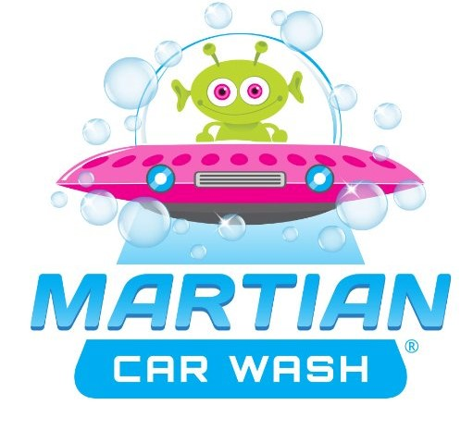
Martian Car Wash
6088 Mid Rivers Mall Dr
St. Peters, Mo
Share with #martiancarwash

